**Name: /50**

1. 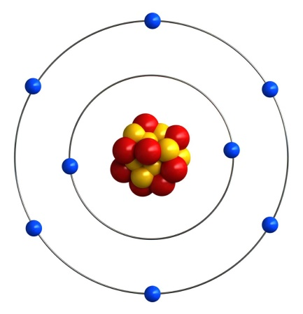Use your knowledge of the atom to complete the table below. [4 marks]

|  |  |  |  |
| --- | --- | --- | --- |
| Sub-atomic particle colour | Sub-atomic particle name | Sub-atomic particle charge | Sub-atomic particle weight |
| Blue |  |  |  |
| Yellow | Proton |  |  |
| Red |  |  |  |

1. What is the name and symbol of the element in the model? [1 mark]
2. What is the electron configuration of this element? [1 mark]
3. What would be the electron configuration of this element if it had a -2 charge? [1 mark]
4. Complete the following table using your periodic table. [6 marks]

|  |  |  |  |  |  |  |
| --- | --- | --- | --- | --- | --- | --- |
| Name | Symbol | Atomic # | Mass # | Protons | Neutrons | Electrons |
| Hydrogen |  |  |  |  |  |  |
|  | K |  |  |  |  |  |
|  |  | 26 |  |  |  |  |
|  |  |  | 14 |  |  |  |

1. Use the periodic table to write a correct symbol for each of the following. [5 marks]

|  |  |
| --- | --- |
| 1. The element that is in group 2 and period 4. |  |
| 1. A noble gas with exactly 3 occupied electron shells. |  |
| 1. An element from group 14 that is a non-metal. |  |
| 1. The element in period 3 that has the largest atomic radius. |  |
| 1. The element in group 16 that has the highest electronegativity. |  |

1. What are the similarities and differences between isotopes of the same atom? [2 marks]
2. Explain why the relative molecular mass of each element is not identical to those found on the periodic table. [2 marks]
3. Silver atoms consist of 51.4% of the isotope 107Ag and 48.6% of the isotope 109Ag   
   Calculate the relative atomic mass of silver, rounding your answer to 1 decimal place. [3 marks]
4. To determine isotope distributions, a mass spectrometer can be used. A mass spectrometer works in four different phases – ionization, acceleration, deflection, and detection. Describe the first three phases below, explaining why we require each step.
   1. Ionization [2 marks]
   2. Acceleration [2 marks]
   3. Deflection [2 marks]
5. At what m/z value (rounded to a whole number) would you expect the following ions to appear at in a mass spectrometer? Using this information, **circle** the ion that would be detected **first**. [3 marks]

Na+:

Fe3+:

1. Bohr based his model of the atom on hydrogen, noticing that when exposed to energy it emitted coloured light of specific wavelengths. Explain why this occurs. [4 marks]
2. Atomic Absorption Spectroscopy (AAS) can be used to detect incredibly low amounts of various heavy metals. Explain how AAS differs to a typical flame test. [2 marks]
3. At a particular crime scene, a man was found murdered at his kitchen table. Suspected to have died of lead poisoning, a forensic scientist decided to use AAS to construct a calibration curve, shown below
4. Name the type of hallow cathode lamp the scientist would have used and explain why this specific one is needed. [2 marks]
5. The lab results indicated that the water the man drank from had an absorbance reading of 0.35. What was the concentration of lead in the drinking water? [1 mark]
6. The NHMRC has a limit of 0.01 mg/L concentration of lead, with anything above this being considered toxic to humans. Determine whether the man was likely to have died from lead poisoning, explaining why. [2 marks]
7. Describe and explain the trends in **electronegativity** down the group and across a period in the periodic table. [5 marks]  
   - include an explanation for electronegativity in your answer.